Pitch Deck Outline: The True Circular Economy

Slide 1: Title & Hook
- Headline: [Your Project Name]
- Sub-headline: Redefining "Plastic to Profit": From Single-Use to Heirloom.
- The Hook: A complete circular economy platform connecting households, DIY artisans, and B2B corporations to exchange waste for tangible wealth. We don't just manage waste; we elevate it.

Slide 2: The Motive & The Problem (Why Competitors Fail)
- The Data: India generates approximately 3.4 million tonnes of plastic waste annually, yet less than 30% is effectively recycled.
- The Logistics Trap: Current startups burn millions on inefficient door-to-door household collection for low-value scrap.
- The Motivation Gap: Households receive pennies per kilo, destroying any incentive to clean or pre-sort their plastic.
- The Downcycling Flaw: Competitors mostly crush plastic into industrial pellets. It’s a low-margin race to the bottom that ignores the creator economy.

Slide 3: Our Vision (The Paradigm Shift)
- Single-Use to Heirloom: We transition from low-margin scrap logistics to a high-margin creator economy.
- Empowering Artisans: We provide DIY creators with cheap, verified raw materials and a premium digital storefront to sell their work.
- The Real Circular Economy: Every stakeholder—the household, the artist, and the platform—profits directly from the exact same piece of plastic.

Slide 4: The 3-Layer Solution (Our Competitive Edge)
Unlike existing platforms that only do logistics, we control the entire lifecycle.
- Layer 1: Community Supply Chain. Event-driven, high-density collection drives bypassing the door-to-door trap.
- Layer 2: AI & Traceability. Frictionless computer vision for instant sorting and NFC tech for transparent profit-sharing.
- Layer 3: The Mega Marketplace. A unified D2C (Direct-to-Consumer) and B2B hub selling luxury upcycled goods, DIY materials, and industrial Eco-Bricks.

Slide 5: Process 1 — Smart Collection (The Operations)
- The Strategy: We model our collection phase after high-energy, large-scale community events like hacktours or youth festivals.
- The Execution: We organize localized, 3-week "Recycling Sprints" at specific college campuses, tech parks, and residential hubs.
- The Result: Instead of sending trucks to 500 individual homes, 500 people bring pre-sorted PET and HDPE to one central smart bin. This creates massive bursts of clean supply with near-zero transportation costs.

Slide 6: Process 2 — AI Classification & Rewards
- Frictionless Logging: When a user drops off plastic, they snap a photo. Our AI Vision API instantly classifies the plastic type (e.g., PET Type 1) and estimates the volume. No manual data entry required.
- The "Up-Coin" Economy: The household's digital wallet is instantly credited with Up-Coins based on the weight and purity of the plastic.
- The Loop: Users can cash out, or strategically spend their Up-Coins to unlock 30-50% discounts on the luxury products in our marketplace.

Slide 7: Process 3 — Recycling & Upcycling Pipelines
How we process the collected materials based on quality:
- Premium HDPE (Type 2): Shredded and melted into stunning, marble-like "sustainable terrazzo" for luxury planters, lampshades, and coasters.
- Premium PET (Type 1): Pultruded into 100% recycled 3D printer filament for engineering students, or spun into rPET yarn for campus event lanyards.
- Mixed Plastics (The Catch-All): Low-grade mixed plastics are compressed with sand and ash under high heat to create Eco-Bricks—interlocking pavers and roofing tiles that are lighter and stronger than concrete.

Slide 8: Process 4 — The Marketplace & The DIY Artisan
- The Digital Boutique: A premium, Next.js-powered storefront where users can purchase the final upcycled goods.
- The Creator Hub: DIY artisans can claim bulk plastic from our campus sprints, craft their products, and list them on our platform.
- Digital Passports: Luxury items feature embedded NFC tags. Buyers tap the product to see its exact origin story—the specific campus drive it came from and the artisan who crafted it.

Slide 9: B2B Integration & The EPR Goldmine (Revenue)
- The Mandate: Since the 2022 guidelines, Indian FMCG companies legally must meet Extended Producer Responsibility (EPR) targets.
- The Revenue Engine: Companies will pay our platform a premium for verified, traceable data showing exactly how much plastic we collected on their behalf.
- Industrial Sales: Selling bulk Eco-Bricks directly to municipalities and construction firms for sustainable urban development.

Slide 10: The Impact
- Environmental: Diverting high-grade plastics from landfills and reducing the carbon footprint of manufacturing new raw materials.
- Social: Creating a new, verified revenue stream for independent DIY artisans and creators.
- Economic: Building a self-sustaining, profitable ecosystem where transparency guarantees trust.

Slide 11: Why We Win This Hackathon
- We solved the logistics: High-density campus sprints solve the unit economics of waste collection.
- We built a premium UX: AI sorting and NFC tracking remove user friction and build absolute trust.
- We engineered for scale: A high-performance frontend backed by the real-time data syncs of Supabase allows us to handle thousands of concurrent marketplace transactions and point updates flawlessly.

Category 1: "No-Melt" Direct Upcycling (Low Effort, High Margin)
These products require zero heavy machinery or melting. They rely on smart cutting, assembly, and aesthetic finishing (like painting or wrapping) to turn raw containers into premium lifestyle goods.
- 1. "Auto-Bloom" Self-Watering Planters
  - Material: 1L or 2L clear PET bottles (Type 1).
  - How it’s made: The bottle is cut in half. The top half (with the cap on, punctured) is inverted and nested into the bottom half. A thick cotton wick is threaded through the cap. The bottom reservoir holds water; the top holds soil and the plant. The outside is wrapped in tight jute rope or painted with matte terracotta paint to hide the plastic and give it a premium, earthy look.
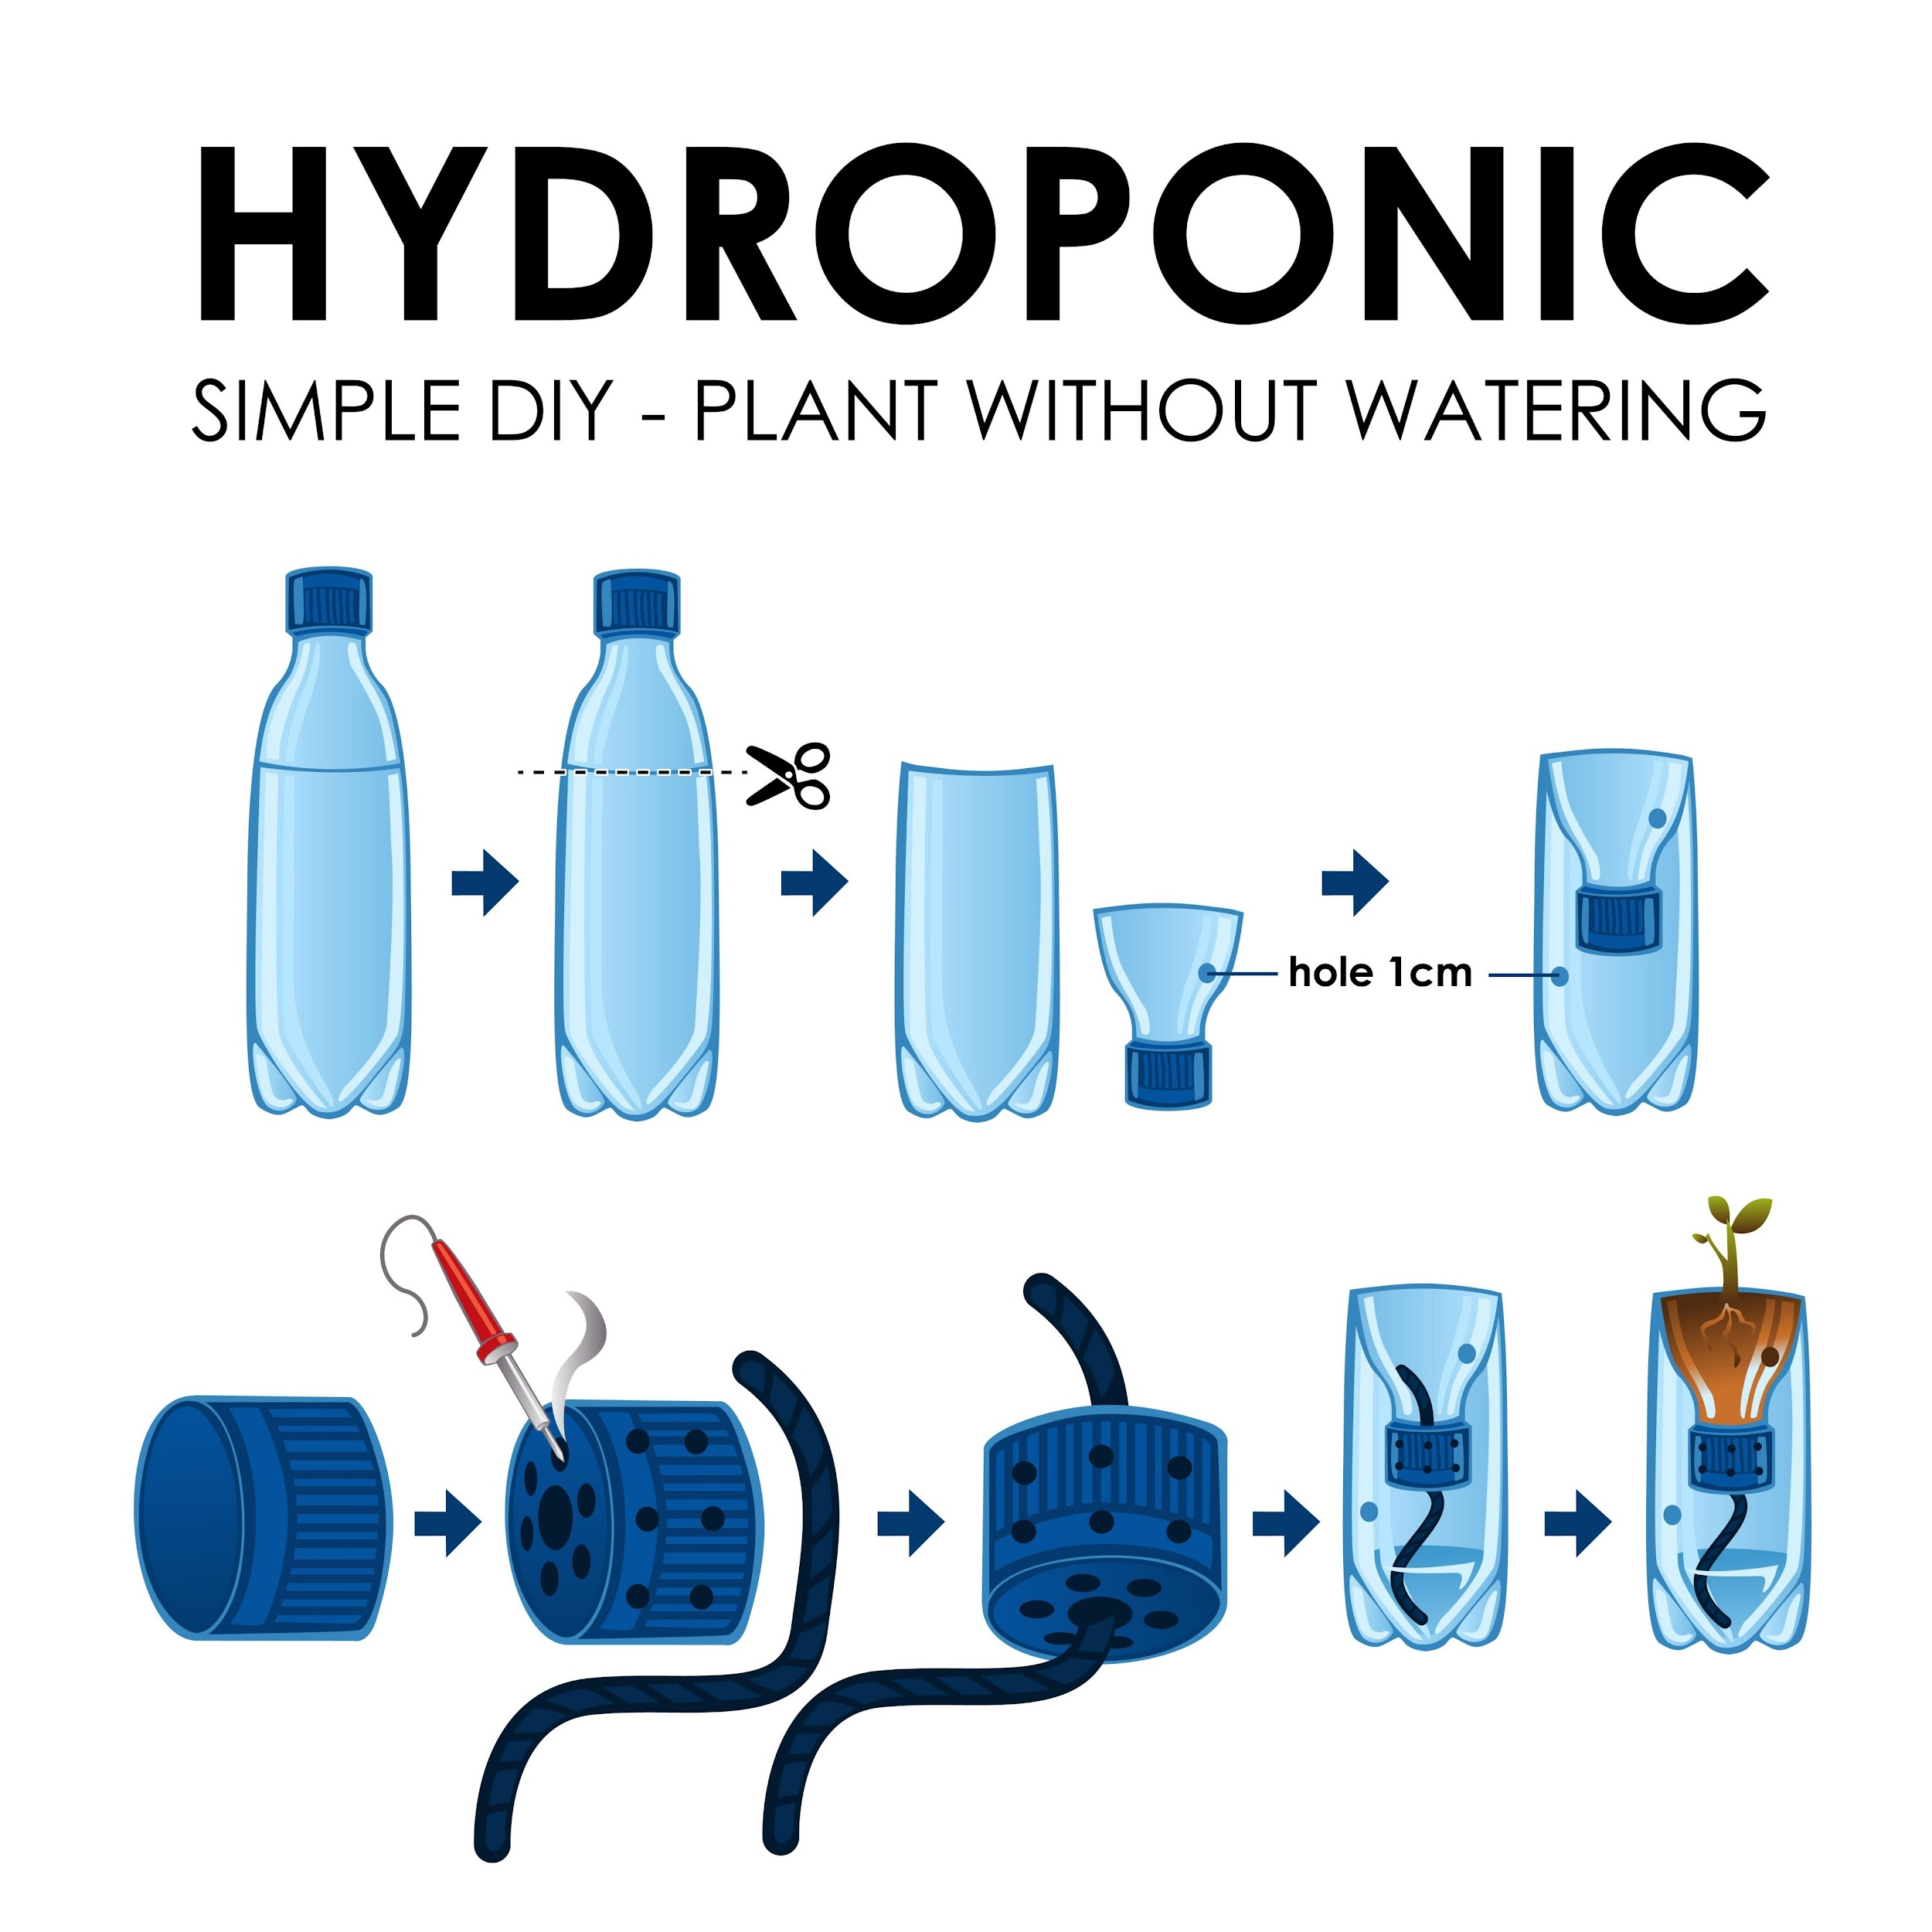
Shutterstock
Explore
* **The Profit:** The raw material is free. By adding ₹20 of jute rope and a ₹50 indoor plant, this retails for ₹250–₹400 as a smart urban gardening solution.

- 2. Upcycled Bucket Ottomans (Seating + Storage)
  - Material: Discarded 20L paint buckets or bulk food containers.
  - How it’s made: The bucket is rigorously cleaned. A circular wooden disc (often scrap plywood) is padded with recycled foam and upholstered with upcycled textile waste to form a lid. The exterior of the bucket is wrapped tightly in thick sisal rope or woven fabric.
  - The Profit: Transforms a bulky waste item into a highly functional piece of dual-purpose living room furniture. Costs ₹150 to make, retails for ₹800–₹1500.

Category 2: Flexible Plastic Solutions (Milk Bags, Polythenes, Wrappers)
You are completely right—thin films cannot be melted easily without releasing fumes or burning. Here is how your artisans turn them into profitable marketplace goods.
- 3. Crocheted "Plarn" (Plastic Yarn) Market Totes & Doormats
  - Material: Washed milk bags, grocery polythenes (LDPE).
  - How it’s made: The bags are cut horizontally into continuous loops and linked together to create balls of thick, waterproof yarn known as "Plarn." Local textile artisans use large crochet hooks to weave this Plarn into heavy-duty grocery totes, beach bags, or textured outdoor doormats.
  - The Profit: This is an incredible socio-economic play. It employs traditional weaving skills while permanently locking away the most problematic plastic waste. Plarn bags are virtually indestructible and highly waterproof.
- 4. Fused-Film Tech Pouches & Travel Kits
  - Material: Courier bags, bubble wrap, thin polythenes.
  - How it’s made: Artisans layer 4 to 6 plastic bags between sheets of parchment paper and apply heat using a standard clothing iron. The layers fuse together to create a thick, waterproof, leather-like material (similar to commercial Tyvek). This fused fabric is then cut and sewn into zipper pencil cases, toiletry bags, or laptop sleeves.
  - The Profit: A brilliant, low-tech way to create commercial-grade, waterproof fabric without industrial extruders.
- 5. Modular Eco-Brick Furniture (The Ultimate Sink)
  - Material: Multi-Layer Plastics (MLP like chips/biscuit wrappers) stuffed into 1L PET bottles.
  - How it’s made: Households tightly pack non-recyclable wrappers into bottles using a wooden stick until the bottle is as hard as a brick.
  - Marketplace Execution: Do not just sell raw Eco-Bricks—sell the finished product. Your artisans use these bricks as the internal structural frame for modular garden benches or coffee tables, binding them together with cob (a natural mixture of clay, sand, and straw) or framing them in reclaimed wood.

Category 3: Artisan Micro-Molding (The "Heirloom" Feel)
These require basic, low-cost heat presses (like a customized sandwich press or a small OTG oven) to create the marbled luxury items.
- 6. Marbled Soap Dishes & Minimalist Coasters
  - Material: Color-sorted HDPE caps and shampoo bottles (Type 2).
  - How it’s made: Plastic is cut into small flakes. Blue and white flakes are mixed, placed into a small, flat silicone or aluminum mold, and baked at 180°C. They cool into heavy, stone-like bathroom accessories.
  - The Profit: Extremely fast to produce. A set of 4 marbled coasters is a classic, highly giftable marketplace staple.
- 7. "Pocket-Space" Wall Organizers
  - Material: Large detergent jugs or bleach bottles (HDPE).
  - How it’s made: The top half and handle are sliced off at an angle. The edges are sanded smooth. A mounting hole is drilled in the back. The resulting curved "pocket" is mounted on walls near front doors to hold keys, mail, or sunglasses.
  - The Profit: Requires literally two cuts and some sanding. Highly functional, minimalist aesthetic.

Here are 20 highly specific, profitable finished products divided by their manufacturing method. This covers everything from zero-heat direct upcycling to low-heat heirloom crafting, ensuring every piece of plastic has a destination.

Category 1: "No-Melt" Direct Upcycling (Zero Heat, High Craft)
These products rely on smart cutting, folding, and aesthetic wrapping. They are perfect for entry-level artisans.
1. "Auto-Bloom" Self-Watering Planters
- Material: 1L or 2L clear PET bottles (Type 1).
- Execution: Bottle cut in half, top inverted into the bottom with a cotton wick through the cap. Wrapped in jute rope or painted terracotta.
2. Upcycled Bucket Ottomans
- Material: 20L paint buckets or bulk food containers.
- Execution: Cleaned bucket topped with a foam-padded scrap wood lid, upholstered with textile waste, and wrapped tightly in thick sisal rope.
3. "Pocket-Space" Wall Organizers
- Material: Large detergent jugs or bleach bottles (HDPE).
- Execution: Top and handle sliced off at an angle, edges sanded smooth. Mounted on walls to hold keys, mail, or sunglasses.
4. Hanging Vertical Garden Modules
- Material: 2L PET bottles.
- Execution: Rectangular windows cut into the sides, suspended horizontally on galvanized wire. Sold in sets of 5 for apartment balcony herb gardens.
5. Woven Magazine / Storage Baskets
- Material: Thick PET strips cut from large water bottles.
- Execution: Bottles are cut into long, continuous 1-inch strips and woven tightly together like traditional bamboo baskets.
6. Minimalist Bird Feeders
- Material: 1L PET bottles and wooden spoons.
- Execution: Holes cut to slide two wooden spoons through the bottle. The spoon bowl acts as the perch and feed catcher.

Category 2: Flexible Film Solutions (Polythenes, Milk Bags, Wrappers)
Thin films cannot be melted in ovens. They must be woven or fused using basic household irons.
7. Crocheted "Plarn" Market Totes
- Material: Milk bags, grocery polythenes (LDPE).
- Execution: Bags cut into continuous loops to create "Plarn" (Plastic Yarn). Crocheted into heavy-duty, waterproof grocery totes.
8. Heavy-Duty Outdoor Doormats
- Material: Dark-colored grocery polythenes.
- Execution: Crocheted or tightly braided plarn. Extremely durable, waterproof, and easily hosed down.
9. Fused-Film Tech & Cable Pouches
- Material: Courier bags, bubble wrap, thin polythenes.
- Execution: 4-6 layers of plastic ironed between parchment paper to create a waterproof, leather-like fabric (similar to Tyvek). Sewn into zipper pouches.
10. Waterproof Laptop Sleeves
- Material: Fused plastic bags + scrap fabric lining.
- Execution: The fused-film fabric is cut and stitched with a padded interior lining made from tailor-scrap textiles.
11. Artisan Notebook Covers
- Material: Fused colorful plastic wrappers (like chip bags).
- Execution: Wrappers are ironed flat to create a durable, colorful, waterproof sleeve that slips over standard notebooks.

Category 3: Low-Heat Micro-Molding (The "Heirloom" Luxury Tier)
Using an OTG oven or sandwich press at around 180°C to melt HDPE into marbled, stone-like luxury goods.
12. Marbled "Terrazzo" Desk Catch-All Trays
- Material: Color-sorted HDPE caps and shampoo bottles (Type 2).
- Execution: Melted and pressed into CNC-molds. Heavy, premium feel for holding keys, coins, or watches.
13. Geometric Minimalist Soap Dishes
- Material: HDPE (Type 2).
- Execution: Molded with deep drainage grooves. Waterproof, drop-proof, and visually striking.
14. Ergonomic Phone & Tablet Stands
- Material: HDPE (Type 2) or PP (Type 5).
- Execution: Injection-molded or pressed into a heavy, angled block. Fits perfectly on modern WFH desks.
15. Artisan Cabinet Knobs & Drawer Pulls
- Material: Color-swirled HDPE (Type 2).
- Execution: Micro-molded into geometric or rounded shapes, fitted with a standard brass screw insert. Instantly upgrades old furniture.
16. Luxury Guitar Picks
- Material: HDPE or PP.
- Execution: Pressed into thin, flat sheets, then stamped out using a heavy-duty punch tool. Edges are sanded for smooth playing.
17. "Sustainable Terrazzo" Coaster Sets
- Material: Highly contrasting HDPE flakes (e.g., pure black mixed with white caps).
- Execution: Pressed flat, cut into precise hexagons, and sanded smooth. Sold in premium sets of 4.

Category 4: Structural & Maker Supply (Closing the Loop)
Products designed for builders, creators, and home decorators.
18. rPET 3D Printer Filament
- Material: Clear PET water bottles (Type 1).
- Execution: Pultruded (pulled through a heated 3D printer nozzle) into a perfect 1.75mm continuous wire and spooled.
19. Modular Eco-Brick Coffee Tables
- Material: PET bottles densely packed with Multi-Layer Plastics (chips/biscuit wrappers).
- Execution: The raw Eco-Bricks are bound together using cob (clay/sand) or framed in reclaimed pallet wood, topped with a glass pane.
20. Acoustic Sound-Dampening Wall Panels
- Material: Mixed crushed plastics and foam waste.
- Execution: Pressed into lightweight hexagonal tiles. Sold in bulk to streamers, podcasters, or offices to absorb room echo.

